Module 2 Assignment: Report on Linux Command Output
This report contains the practice of 10 basic Kali Linux commands. For each command, I have written what the command does, mentioned at least two arguments, and screenshots after running the commands in terminal.

Command 1: ls
What it does: Lists the files and directories in the current working directory.
Arguments:
- - ls -l → Shows files in long listing format
- - ls -a → Shows all files, including hidden ones
Screenshot:
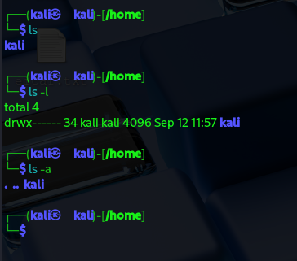

Command 2: pwd
What it does: Displays the present working directory.
Arguments:
- - pwd -L → Shows the logical path (with symbolic links)
- - pwd -P → Shows the physical path (resolving symbolic links)

Screenshot:
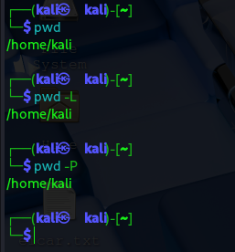

Command 3: cd
What it does: Changes the current directory.
Arguments:
- - cd /home → Goes to the /home directory
- - cd .. → Moves one level up in the directory structure
Screenshot:
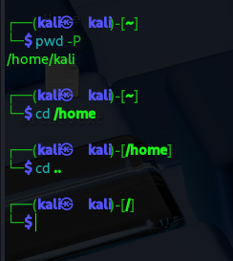

Command 4: cat
What it does: Displays contents of a file.

Arguments:
- - cat demo.txt → Shows the file content
- - cat -n demo.txt → Shows file content with line numbers
Screenshot:
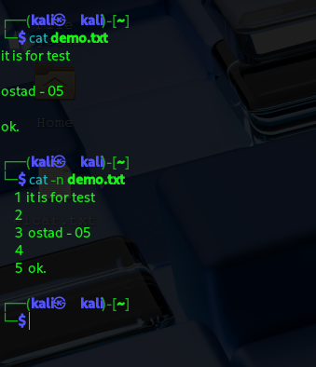

Command 5: cp
What it does: Copies files or directories.
Arguments:
- - cp demo.txt demo-2.txt → Copies file1 into file2
- - cp -r dir.1 dir.2 → Copies directory recursively
Screenshot:
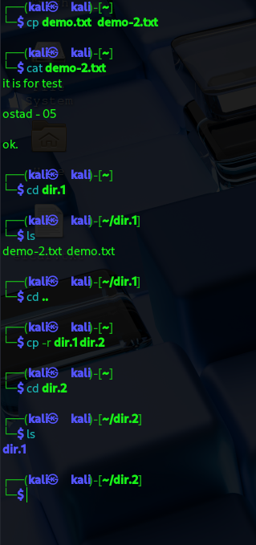

Command 6: mv
What it does: Moves or renames files.
Arguments:
- - mv oldname.txt newname.txt → Renames a file
- - mv file.txt /home/user/ → Moves file to another directory

Screenshot:
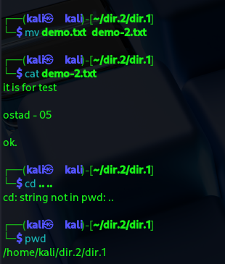
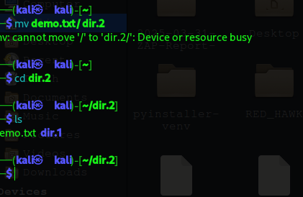

Command 7: rm
What it does: Deletes files or directories.
Arguments:
- - rm file.txt → Deletes a file
- - rm -r folder/ → Deletes a directory recursively
Screenshot:
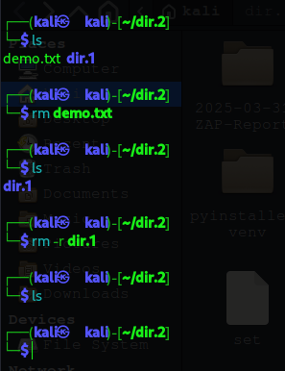

Command 8: mkdir
What it does: Creates a new directory.
Arguments:
- - mkdir newfolder → Creates a folder
- - mkdir -p folder1/folder2 → Creates parent directories if not existing
Screenshot:
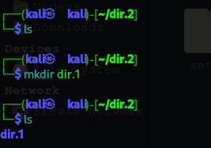 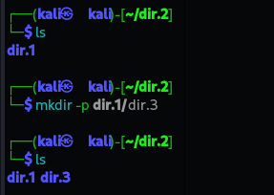

Command 9: touch
What it does: Creates an empty file or updates file timestamps.
Arguments:
- - touch file.txt → Creates a new empty file
- - touch -c file.txt → Updates timestamp only if file exists
Screenshot:
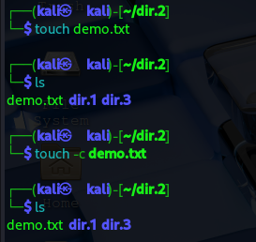

Command 10: man
What it does: Displays the manual page of any command.

Arguments:
- - man ls → Shows manual of ls command
- - man -k network → Searches for all commands related to 'network'
Screenshot:
